Name___________________/ Date______________

1. Which of the following is FALSE when comparing RNA and DNA?   
   A. Both are produced by phosphodiester linkages.  
   B. Both are composed of phosphate groups.  
   C. Both are composed of sugars.  
   **D. Both are composed of identical nucleotides.**  
   E. Both are composed of a phosphate group, a pentose sugar, and a nitrogenous base.
2. What is the complement DNA strand to 5′-ATTCGGTGA-3′?   
   A. 5′-TAAGCCACT-3′  
   B. 3′-CGGATTGTC-5′  
   C. 5′-CGGATTGTC-3′  
   **D. 3′-TAAGCCACT-5′**  
   E. 3′-ATTCGGTGA-5′
3. During DNA replication, all of the following proteins are important for separating the DNA strands and allowing movement of the replication fork EXCEPT   
   **A. DNA polymerase.**  
   B. helicase.  
   C. topoisomerase.  
   D. single-stranded binding proteins.  
   E. both helicase and topoisomerase.
4. Which of the following acts as a carrier of foreign DNA and is needed to clone a gene?   
   A. plasmid  
   B. viral vector  
   C. fungal vector  
   **D. plasmid and viral vector**E. viral vector and fungal vector
5. Which of the following statements is TRUE of restriction enzymes?   
   A. They are not naturally produced by bacteria, but are bioengineered by them.  
   **B. They protect bacterial cells from invasion by foreign DNA.**  
   C. There are less than 10 restriction enzymes known.  
   D. They cleave the DNA backbone at only one location.  
   E. They cleave DNA only at sites of adjacent thymine bases.
6. A small amount of DNA is collected from a crime scene. The amount of DNA collected is insufficient to perform the necessary experiments to link a suspect to the crime. What method could be utilized to increase the amount of DNA?   
    A. Southern blotting  
    B. gel electrophoresis  
    **C. polymerase chain reaction (PCR)**  
    D. colony hybridization  
    E. DNA sequencing
7. A mutation that converts a codon to a stop codon, resulting in premature termination of protein synthesis is known as
   1. Silent mutation
   2. Frameshift mutation
   3. **Nonsense mutation**
   4. Missense mutation

8. Agarose gel electrophoresis separates DNA molecules on the basis of:

* 1. the nucleotide sequence of their sticky ends that were generated by restriction enzymes.
  2. Their nucleotide sequences.
  3. The amount of adenine they contain relative to the amount of thymine they contain.
  4. The mount of adenine they contain relative to the amount of guanine they contain.
  5. **Their size (lengths).**

9. You have a 10X solution of TBE in your laboratory. You need to make 500mL of a 1X solution to finish running your gel. How much of the 10X solution should you add to water to make your 1X solution?

1. 5 mL
2. 500 mL
3. **50 mL**
4. 10 mL
5. 100 mL

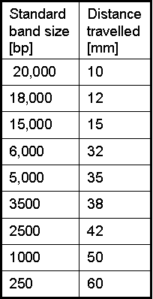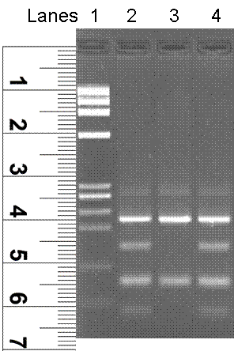**Examine the image and the table. This is an image of an agarose gel, a ruler was used to measure how far each of the bands in the first lane migrated from the top of the gel. This information (see table below) was then used to generate a standard curve. Please use the information below to identify the chart that shows the standard curve prepared using the information below.**

10. The chart representing the standard curve generated using information above is:

1. Chart A
2. **Chart B**
3. Chart C
4. Chart D

11. When a yeast cell has homologous pairs of chromosomes it is said to be

1. Haploid
2. Autologous
3. Heterologous
4. **Diploid**
5. Mutated

12. In Genetic Nomenclature *his3*- means:

1. we are dealing with a protein, specifically an enzyme synthesizing histidine
2. **we are looking at a recessive *his3*-allele, in yeast requiring histidine**

**supplementation in media**

1. it is a dominant gene allele
2. wild type gene coding for a histidine synthesizing enzyme

13. In PAGE analysis we used a certain agent to help us give proteins charge and denature them, the name of the agent is:

a. Ethidium Bromide

b. B-mercaptoethanol

**c. sodium dodecyl sulfate**

d. dithiotreitiol

14. To transform yeast means to:

a. Convert one strain of yeast into another

**b. Introduce foreign DNA into a yeast cell, which is inherited and expressed**

c. Add an antibiotic to the growth media to allow for survival of one strain of yeast

d. Insert a gene into a specific yeast strain that can only be copied but NOT expressed

15. Open Reading Frame (ORF) for a gene represents

**a. Complete set of expressed sequences (exons)**

b. Complete set of intervening sequences (introns)

c. Combined set of introns and exons

d. Complete set of amino acids

e. Product of the gene replication

16. Which of these internet links is best suited for obtaining a complete nucleotide sequence (both introns and exons) for the human MSH2 gene:

a. Google

b. Wikipedia

**c. Pubmed**

d. Yahoo

e. Bing

17. During which biological event is base substitution mutation most likely to occur in the cell?

a. Transformation

b. Bulk sequence deletion

c. PCR

**d. Replication**

e. Translation

18. SDS-PAGE is a technique used to:

a. quantify the amount of proteins present in a sample

b. can be used as a step in western blotting or immunoprecipitation

c. separate proteins based on their size

d. Only A and C are true

**e. All of the above are true**

19. Hallmarks of a cancer cell include all of the following EXCEPT:

a. ability to go through cell cycle check points without proper DNA repair

b. ability to avoid apoptosis

c. ability to promote formation of new blood vessels

d. **ability to differentiate into a specialized cell**

e. ability to invade local tissues and metastasize

20. Major source of restriction enzymes are...:

a. liver cells

b. pancreatic cells

**c. bacterial cells**

d. B cells

e. yeast cells

21. Which of the following should NOT be included in an abstract of a paper?

a. hypothesis

**b. acknowledgements**

c. summary of methods

d. summary of results

e. conclusions

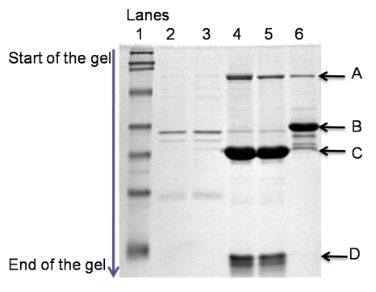Figure below depicts five different samples containing protein mixture extracted from variety of cells and one standard protein marker. When it comes to protein separation, the gel functions as a big sieve: the bigger the protein the slower it runs on the gel, the smaller the protein the further on the gel it will migrate. The thickness of the bands indicates relative amount of protein (the thicker the band the more protein there is) in each sample. Labels on the gel (A – D) point to different proteins. Numbers 1-6 indicate lanes. Based on this information and the figure below please answer the following questions:

22. Which lane(s) contains the highest level of protein A?

* 1. Lane 3
  2. Lane 2
  3. **Lane 4**
  4. Lane 5

1. Sample in lane 4 has higher level of protein A than protein C.
   1. True
   2. **False**
   3. Cannot be determined
2. In lane 6 protein B is larger in size than protein A
   1. True
   2. **False**
   3. Cannot be determined
3. Which of the proteins shown on the gel has the lowest molecular weight?
   1. Protein A
   2. Protein B
   3. Protein C
   4. **Protein D**

Two tubes of plasmid DNA samples (pX and pY) were mixed up, and you were called upon to tell them apart. Plasmids are small, circular, extrachromosomal DNA. Both pX and pY plasmids are 5000 bp (base pairs) long. Maps illustrating each plasmid’s features are provided below.

|  |  |
| --- | --- |
| • KanR: Kanamycin resistance gene  • restriction enzyme name (location):  EcoRV (1261st bp)  HindIII (1942nd bp)  SmaI (3931st bp) | • AmpR: Ampicillin resistance gene  • restriction enzyme name (location):  HindIII (173rd bp)  EcoRV (1573rd bp)  SmaI (3931st bp) |

You digested the plasmid DNAs with different combinations of restriction enzymes, and separated them by gel electrophoresis (lane 2 to 5) along with a DNA ladder (lane 1). A gel image is provided below:



* Restriction enzyme: an enzyme that cuts DNA at specific recognition sites * Gel electrophoresis: a method for separating DNA, RNA or protein fragments, based on their size and charge. * DNA ladder: a mixture of DNA molecules of different lengths used in agarose gel electrophoresis

1. Which lane is more likely to be a sample of pX vector digested with HindIII and EcoRV?
   1. Lane 2
   2. Lane 3
   3. **Lane 4**
   4. Lane 5
2. Which lane is more likely to be a sample of pY vector digested with SmaI, HindIII, and EcoRV?
   1. Lane 2
   2. **Lane 3**
   3. Lane 4
   4. Lane 5
3. Which lane is more likely to be a sample of pY vector digested with HindIII and EcoRV?
   1. Lane 2
   2. Lane 3
   3. Lane 4
   4. **Lane 5**
4. Which lane is more likely to be a sample of pX vector digested with SmaI, HindIII, and EcoRV?
   1. **Lane 2**
   2. Lane 3
   3. Lane 4
   4. Lane 5
5. Please provide an alternative method to distinguish pX from pY.
   1. Gel electrophoresis after restriction digestion with SmaI
   2. Gel electrophoresis after restriction digestion with HindIII
   3. **Ampicillin selection after transforming *E.coli* with the plasmid**
   4. Kanamycin selection after restriction digestion with HindIII